

**A PROJECT REPORT ON**

**Creating a social media Ad Campaign in Facebook**

**DOMAIN:** Digital Marketing

**DOCUMENTATION**

**UNDER THE GUIDANCE OF**

**Industry Mentor(s) Name** : Abdul Malick

**Faculty Mentor(s) Name** : Er.M. Devanathan.

**TEAM ID**: NM2023TMID06144

**SUBMITTED BY**:

R.Bakiyalakshmi 421320106007

P.Manimegalai 421320106021

M.Priyanka 421320106026

R.Swetha 421320106036



**DEPARTMENT OF ELECTRONICS AND COMMUNICATION ENGINEERING**

**KRISHNASAMY COLLEGE OF ENGINEERING & TECHNOLOGY**

**ANNA UNIVERSITY: 2020-2024.**

## BONAFIDE CERTIFICATE

## Certified this project report “ Creating a social media Ad Campaign in Facebook ” is the bonafide work of R.Bakiyalakshmi (421320106007), P.Manimegalai(421320106021), M.Priyanka(421320106026), R.Swetha(421320106036) who carried out the project under my supervision.

|  |  |
| --- | --- |
| **SIGNATURE**  **HEAD OF THE DEPARTMENT**  Er. S. Senthazhai M.E.,  **Associate Professor**  Electronics & Communication Engineering  Krishnasamy College of Engineering & Technology, Cuddalore – 607109. | **SIGNATURE**  **COURSE CO-ORDIATOR**  Er. M. Devanathan, M.E.,  **Assistant Professor**  Electronics & Communication Engineering  Krishnasamy College of Engineering & Technology,  Cuddalore – 607109. |

**IMPLEMENTATION OF THE CREATION A SOCIAL MEDIA AD CAMPAIGN IN FACEBOOK**

**STEP 1:** Create a Brand Name and Logo

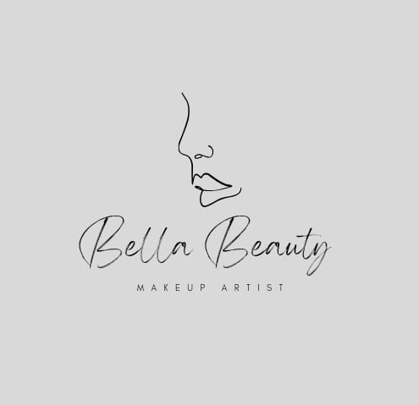

**STEP 2:** Create an email id for the brand (bellabeautymakeupartist837@gamil.com)

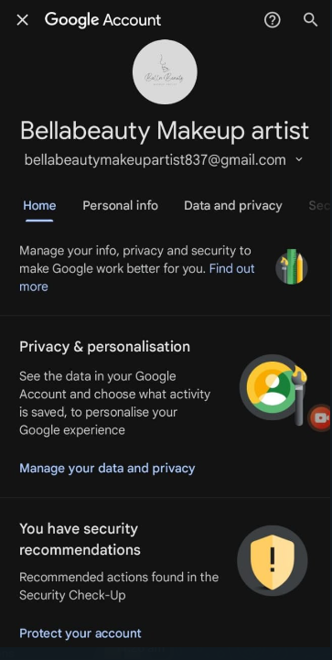

**STEP 3: Search facebook login in Google**

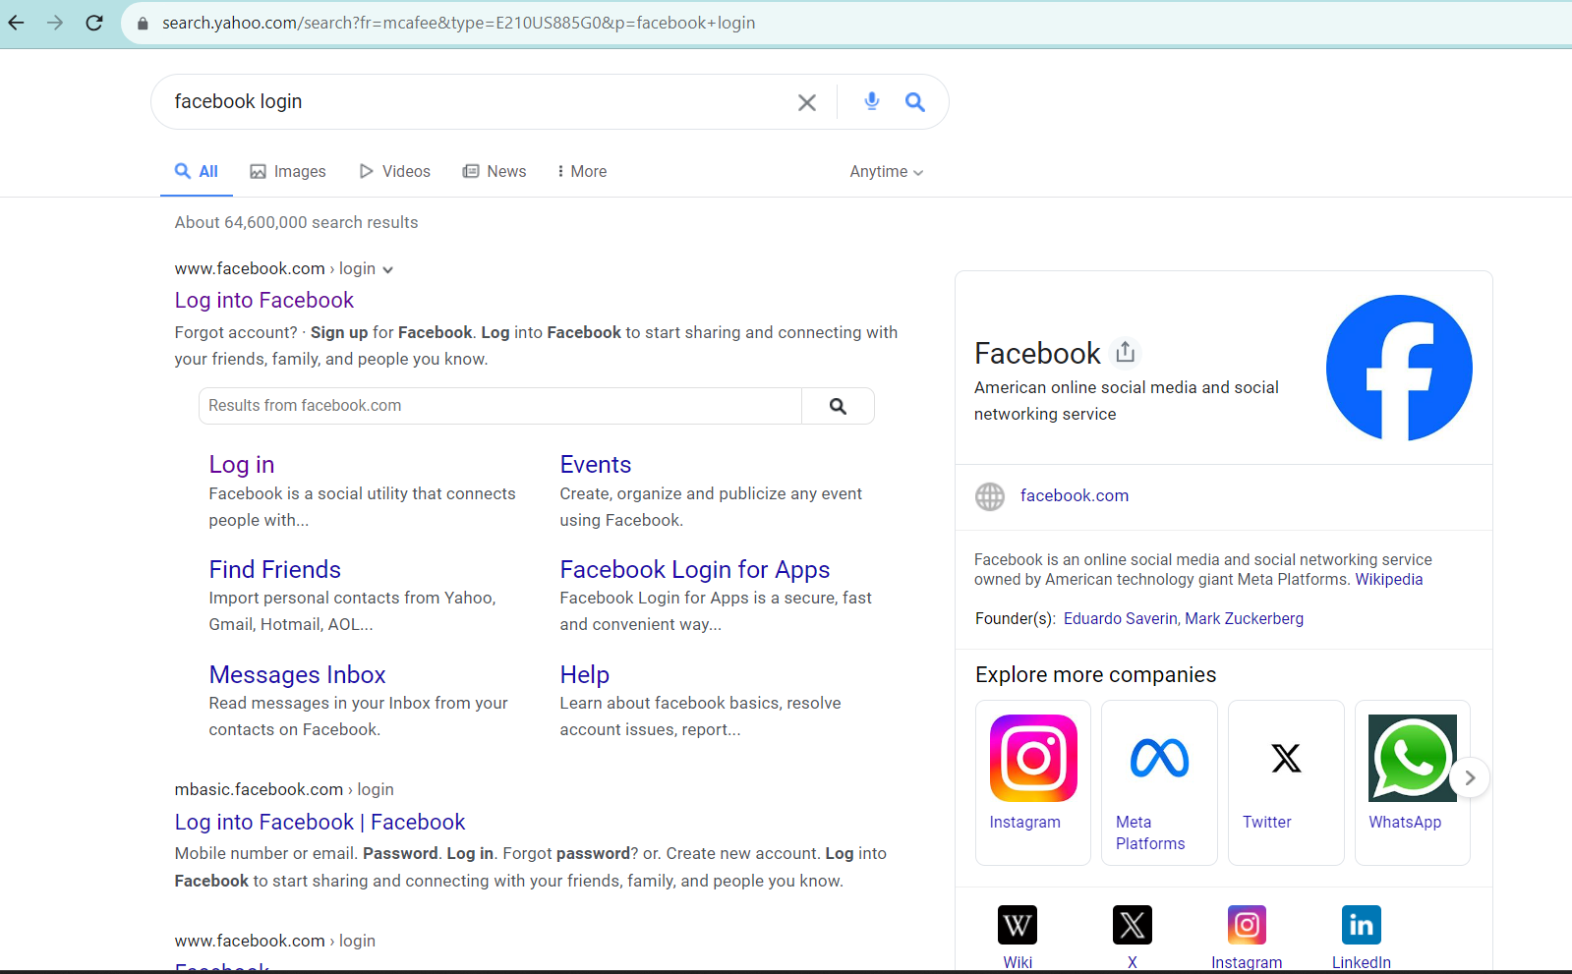

**STEP 4:** Sign up Facebook

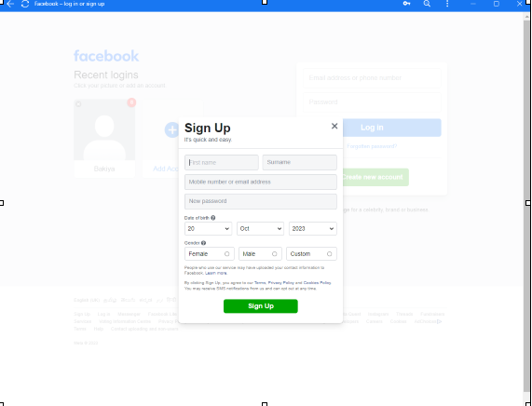

**STEP 5:**Create a Facebook Business page for the brand (https://www.facebook.com/bella.beauty.makeup.artist.2023?mibextid=ZbWKwL)

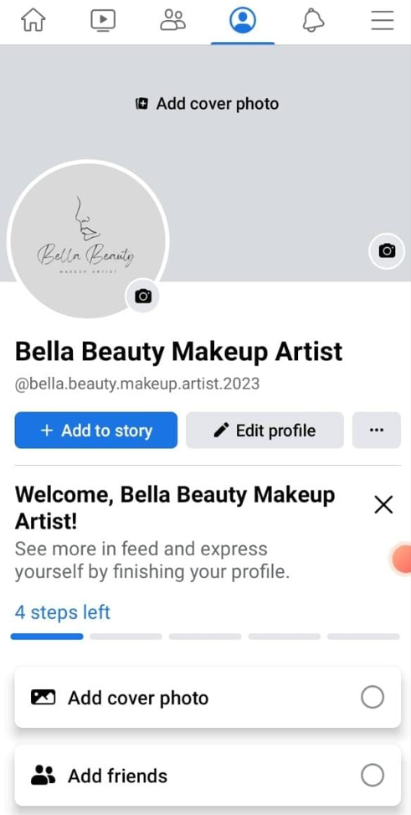

**STEP 6:**Create a social media poster using canva.

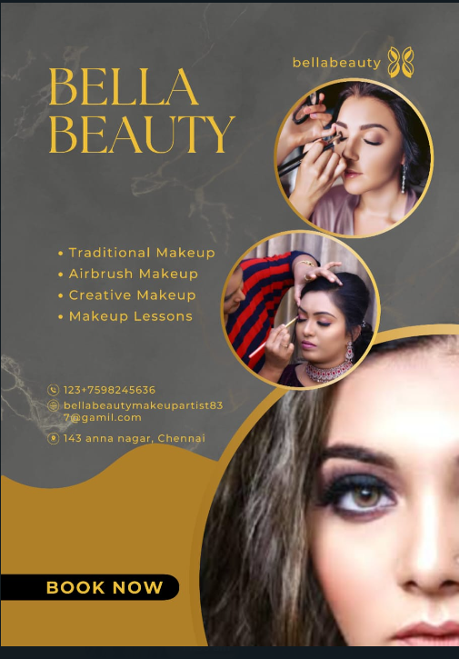

**STEP 7:** Upload a social media poster in facebook business page with hashtags**.**

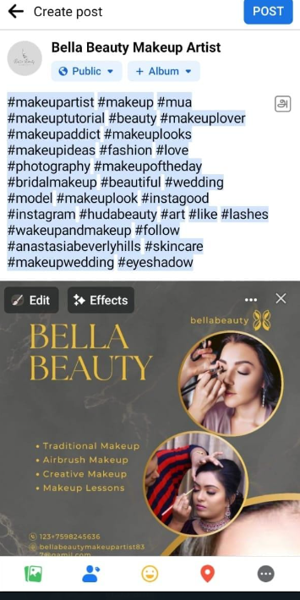

**STEP 8**: Create ad using canva

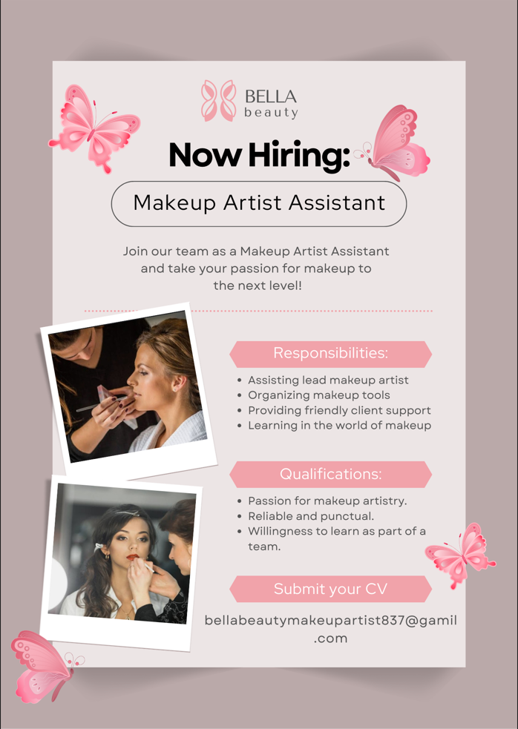

**STEP 9:** Create Meta business suit page

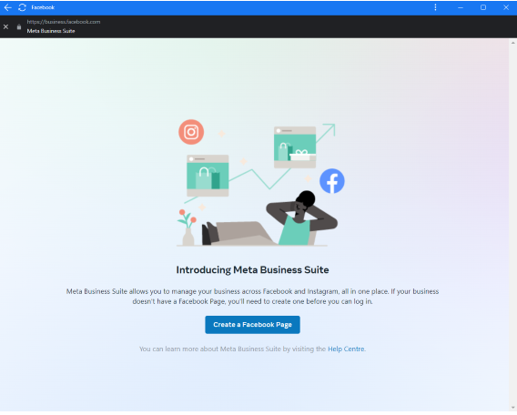

**STEP 10**: Meta business page is created

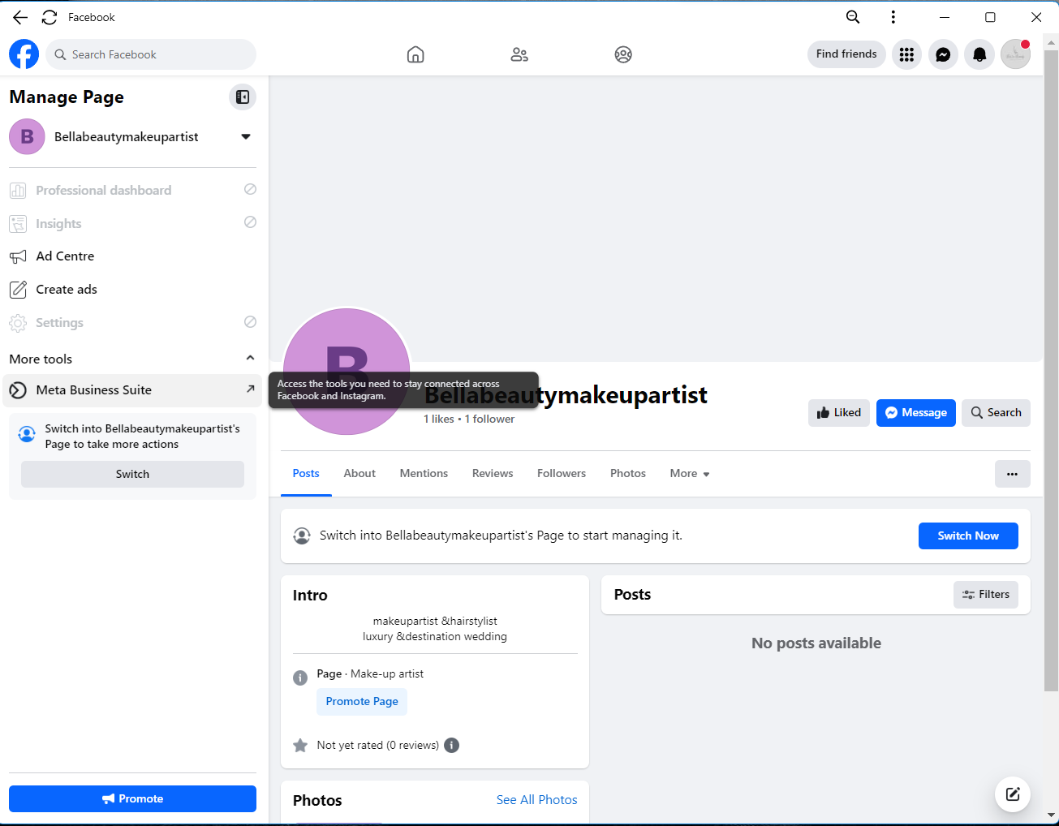

**STEP 11:** Go to the ads

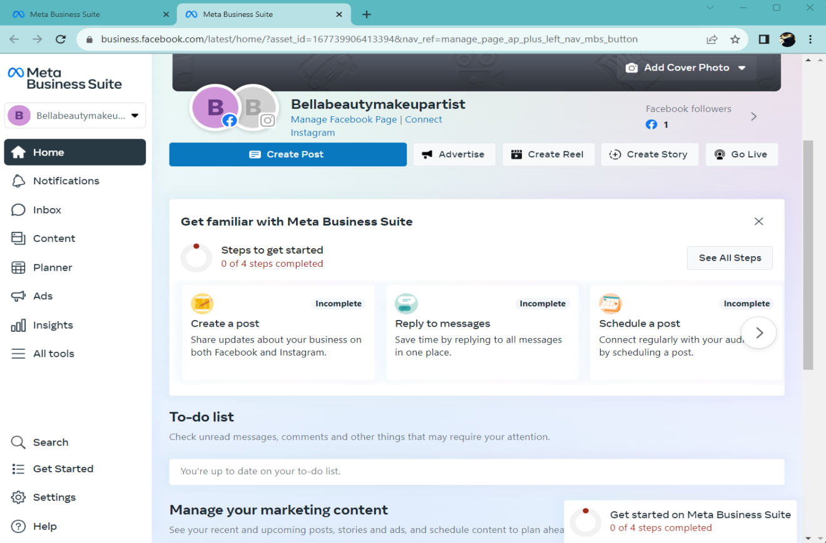

**STEP 12:** Click “create ad**”**

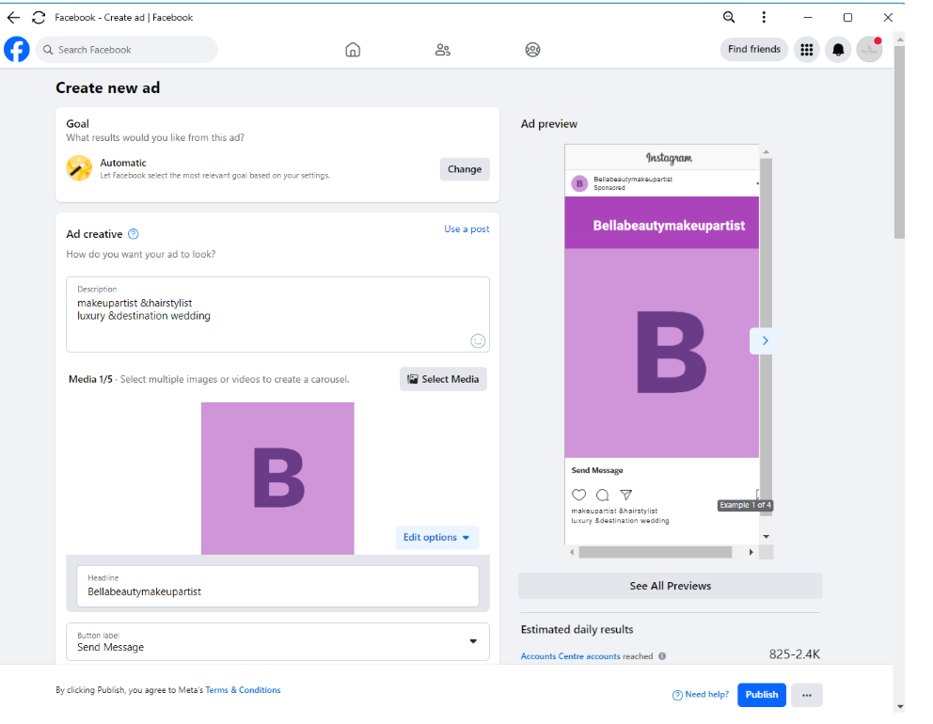

**STEP 13:** Choose goal

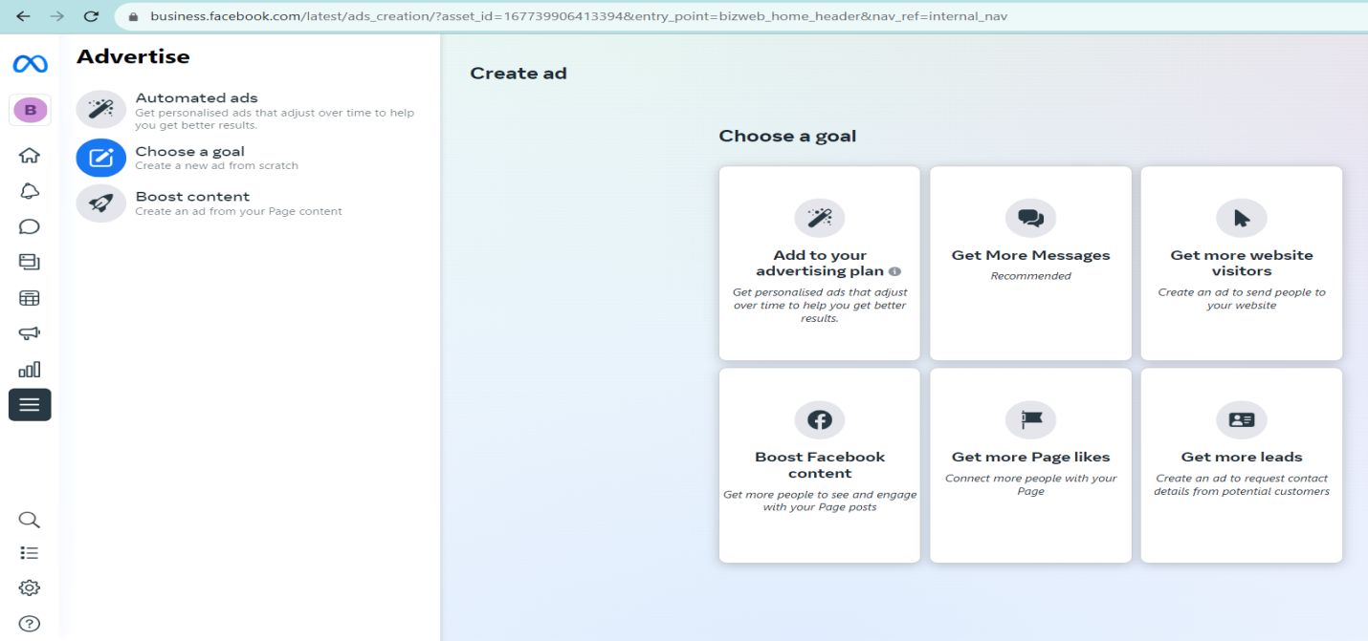

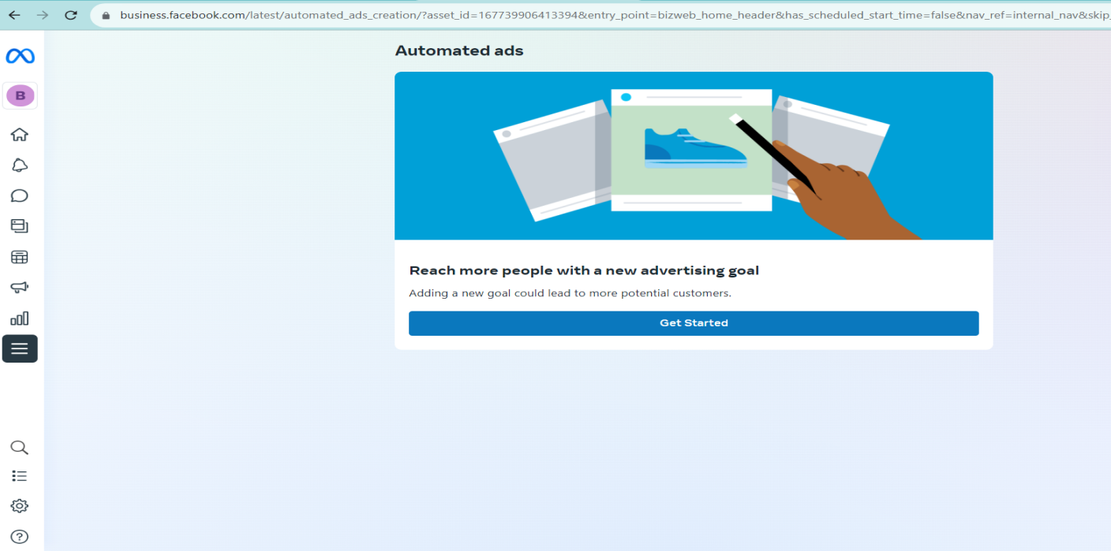

**STEP 14:** Choose Location

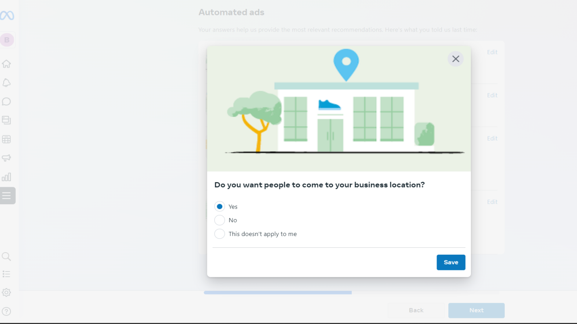

**STEP 15:** Choose website

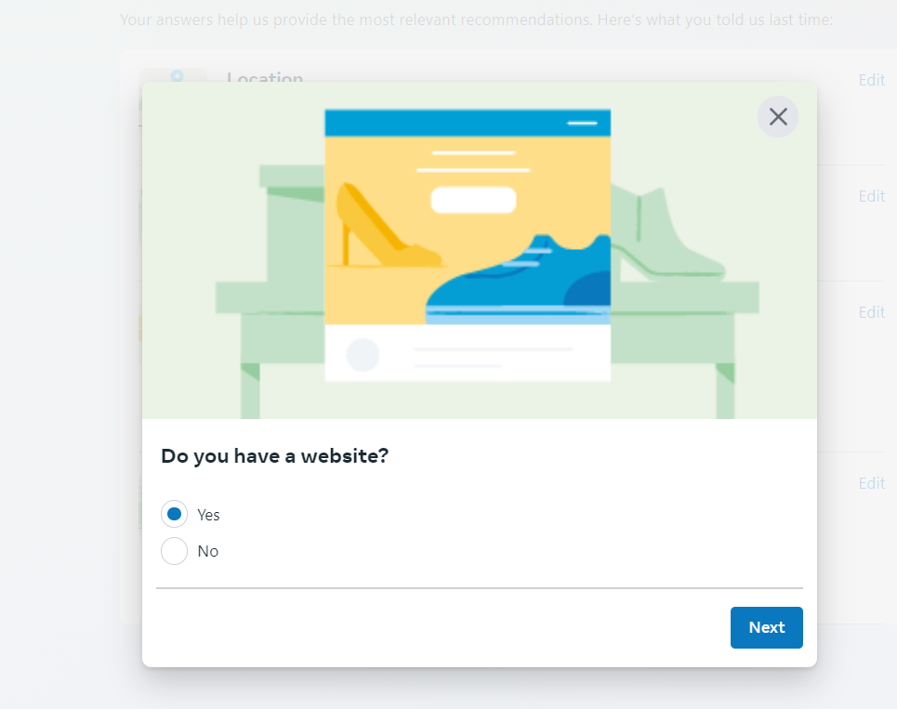

**STEP 16:** Choose contact

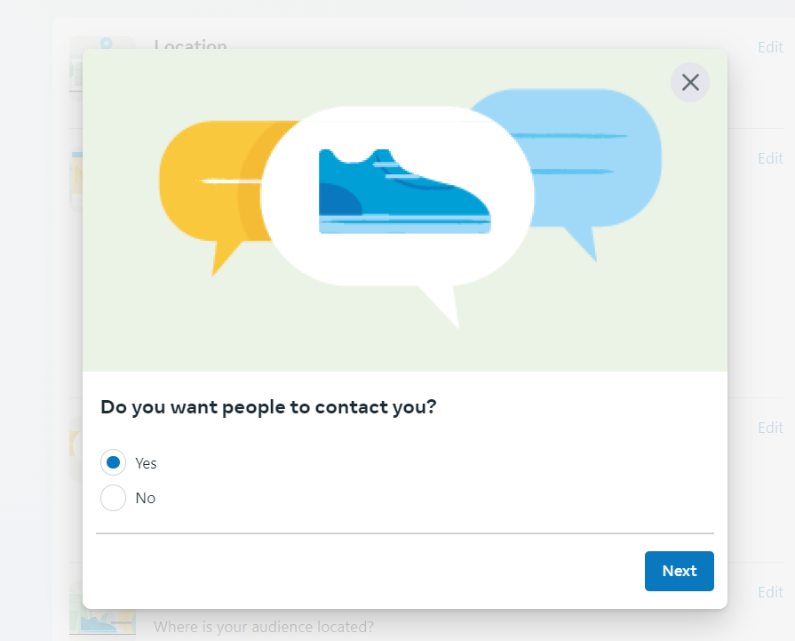

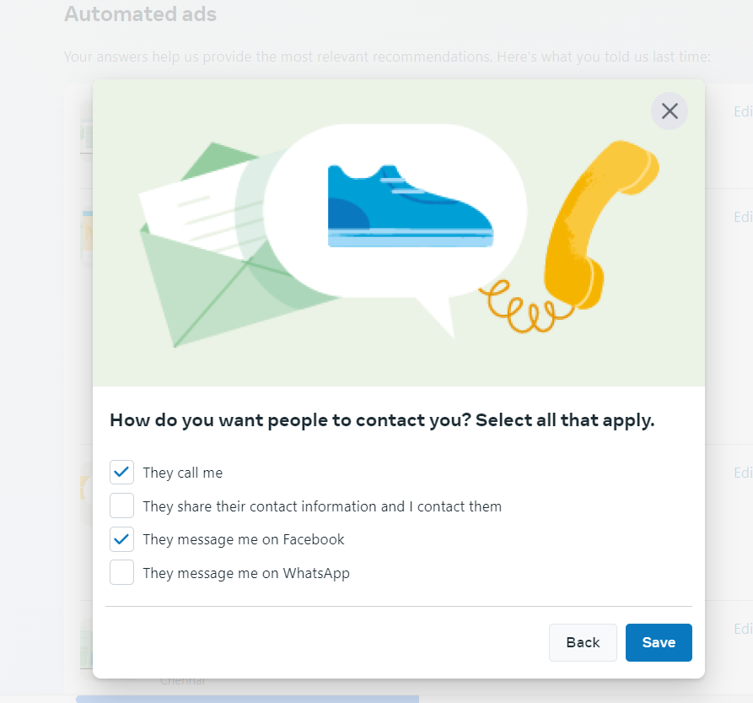

**STEP 17**: Choose Audience location

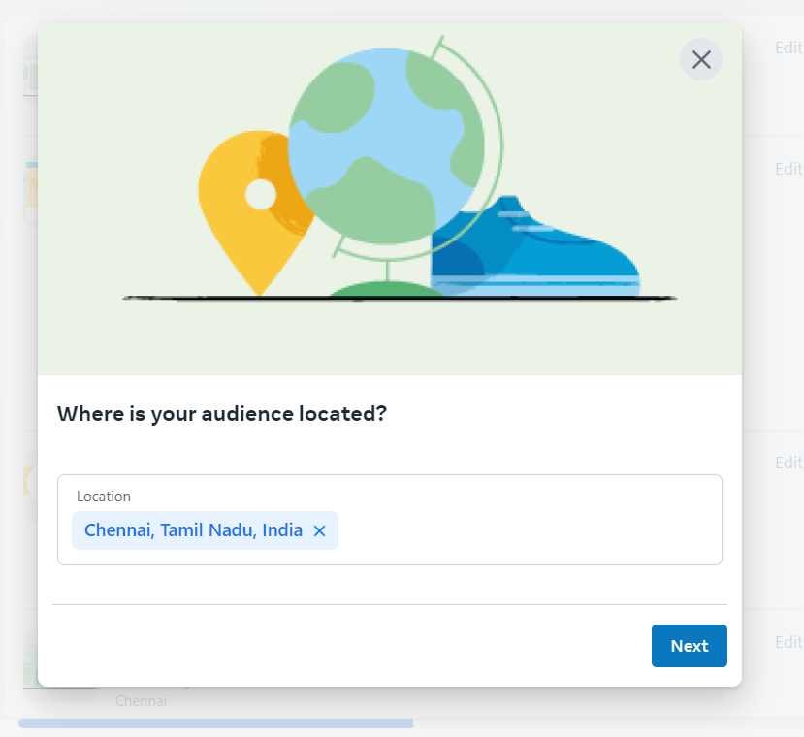

**STEP 18:** Click “select media” and click upload &upload image for your ad

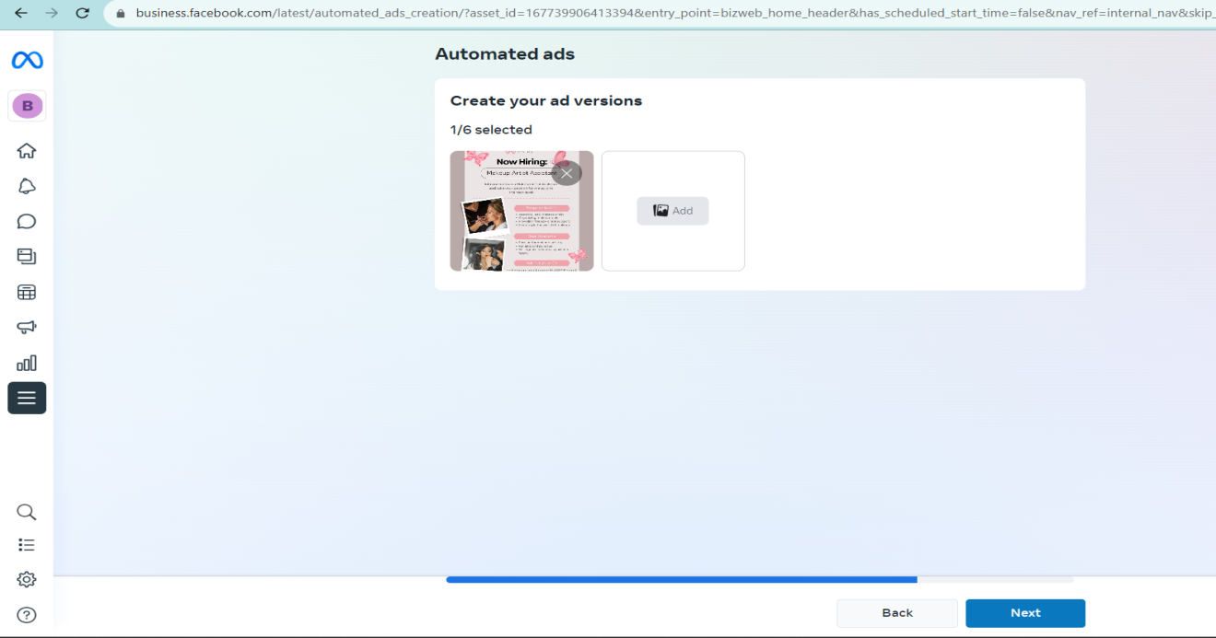

**STEP 19:** Adding Headline for the ad

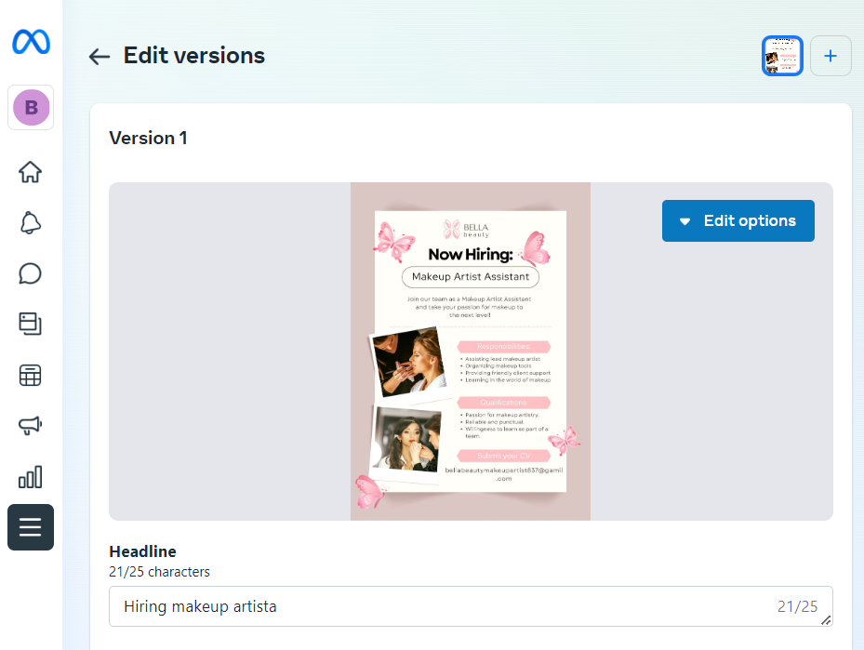

**STEP 20:** Add description

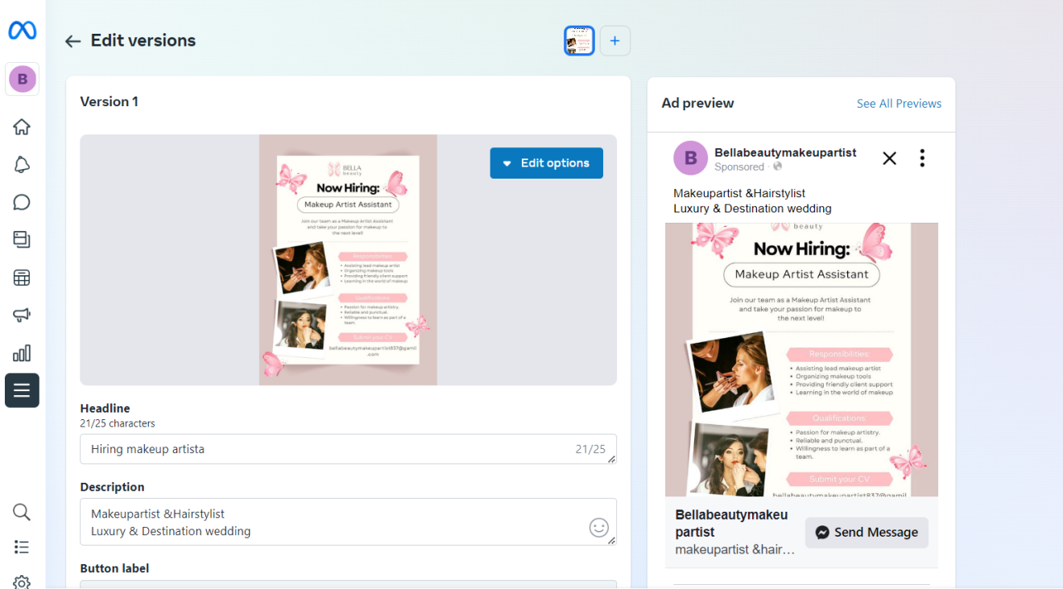

**STEP 21:** Detailed targeting and adding demographics, interests ,Behaviours

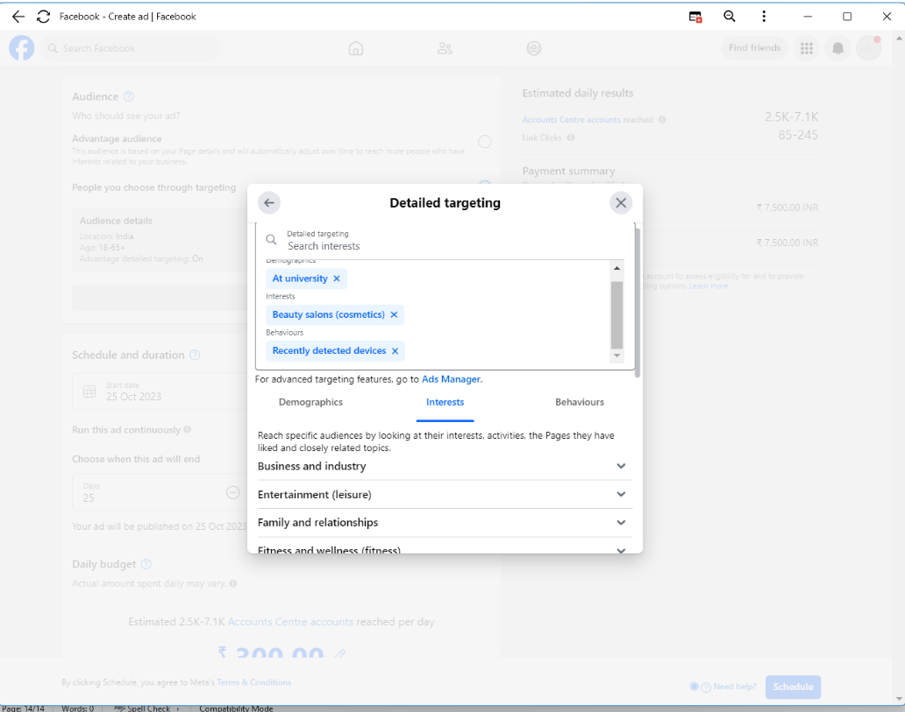

**STEP 22**: Ad Duration

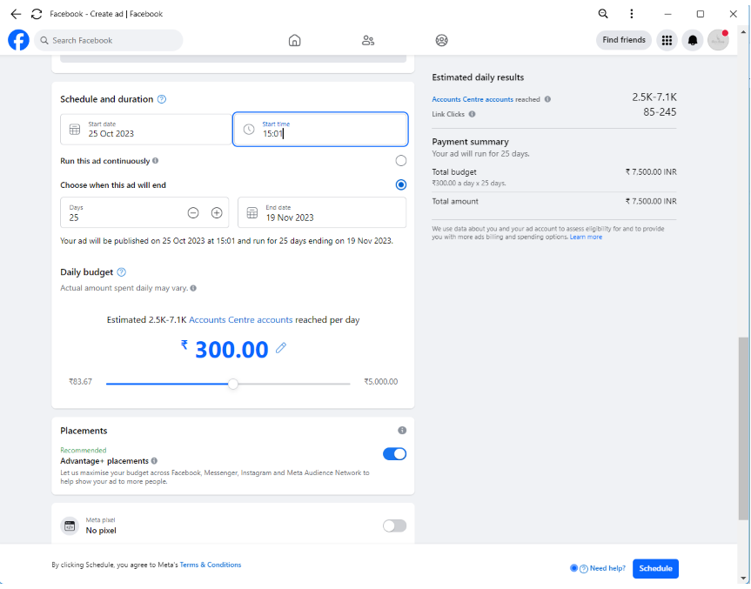

**STEP 23:** Ad Budjet

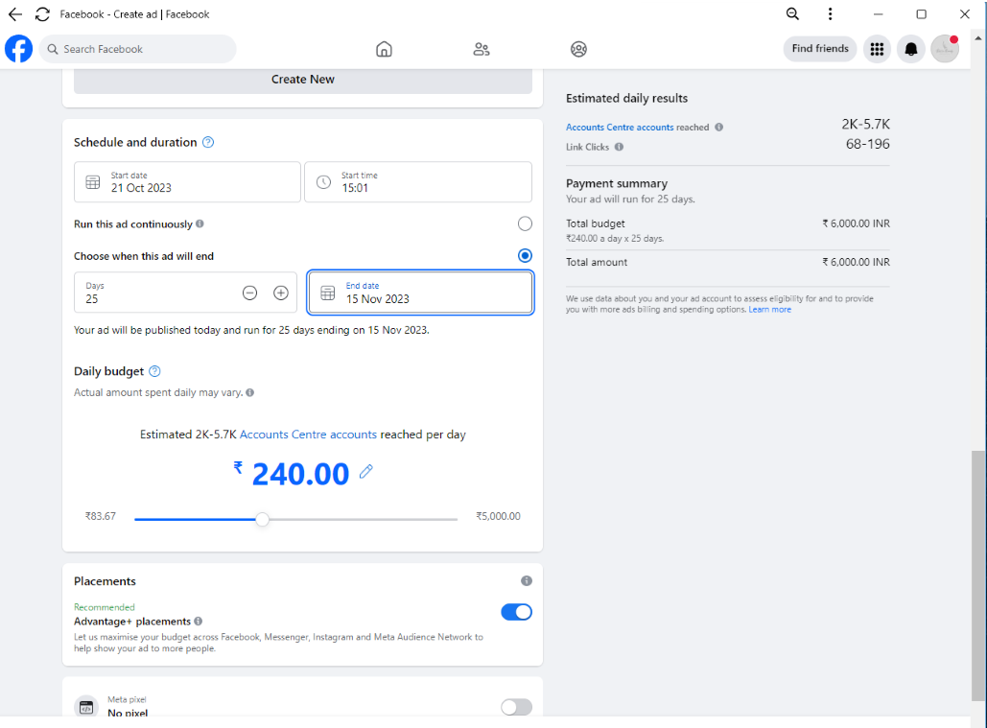

**STEP 24:** Click all Preview

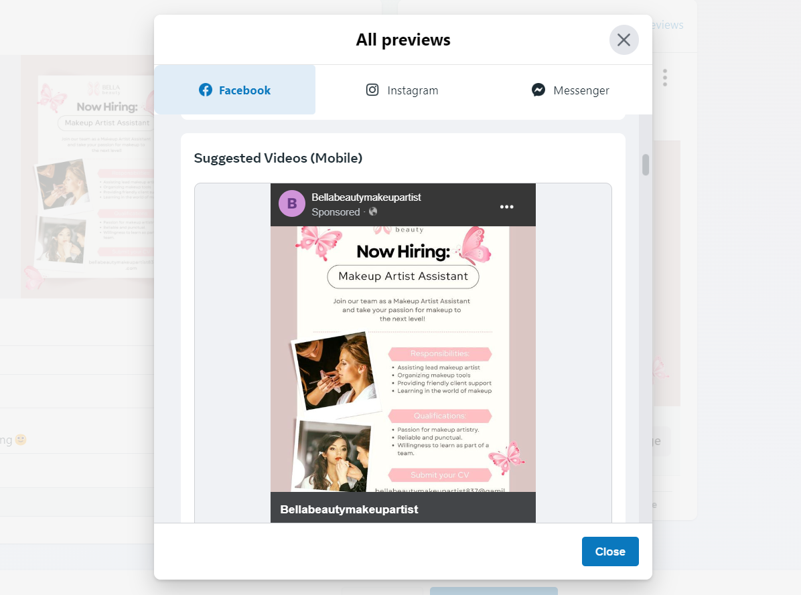

**STEP 25:** Publish add

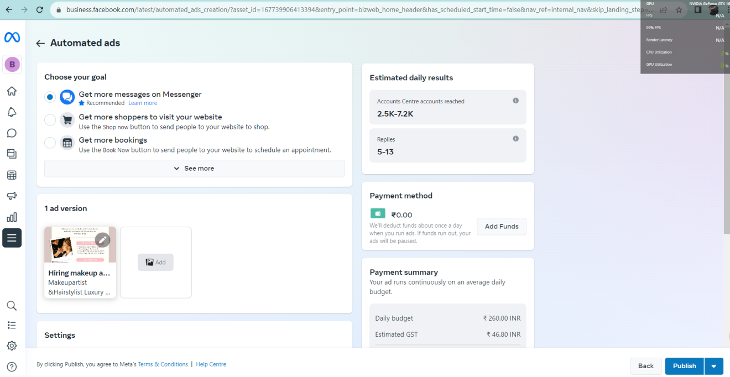

**STEP 26:** Ad being created

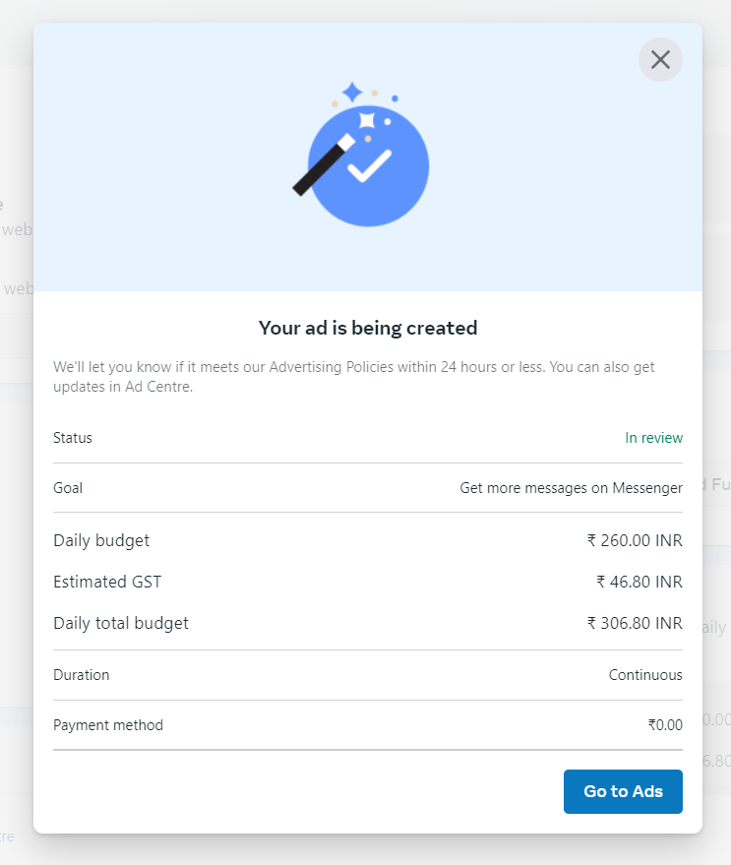

**Our Social Media Accounts :**

* **FACEBOOK : Bella Beauty Makeup Artist**
* **GMAIL :** bellabeautymakeupartist837@gmail.com
* **BLOG ID :https://bellabeautymakeupartist.blogspot.com/?m=1**